**LAB#09**

**OBJECT: Implement the circuit of half adder.**

**Sum = A⊕B**

**Carry = A.B**

**APPARATUS:**

* 74LS08
* 74LS86
* Bread Board
* Connecting Wires
* LED
* DC Supply

**SYMBOLS:**

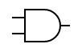

AND GATE

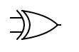

XOR GATE

**TRUTH TABLE:**

|  |  |  |  |
| --- | --- | --- | --- |
| **INPUT** | | **OUTPUT** | **OUTPUT** |
| **A** | **B** | **Sum = A⊕B** | **Carry = A.B** |
| 0 | 0 | 0 | 0 |
| 0 | 1 | 1 | 0 |
| 1 | 0 | 1 | 0 |
| 1 | 1 | 0 | 1 |

**CIRCUIT DESIGN:**

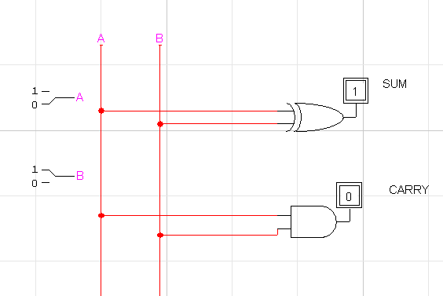

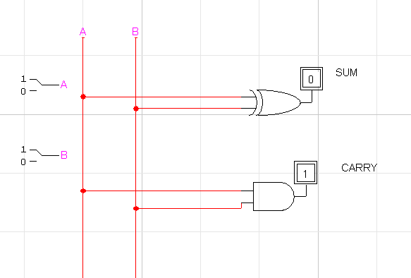

**CONCLUSION:**

The circuit is working according to the truth table.